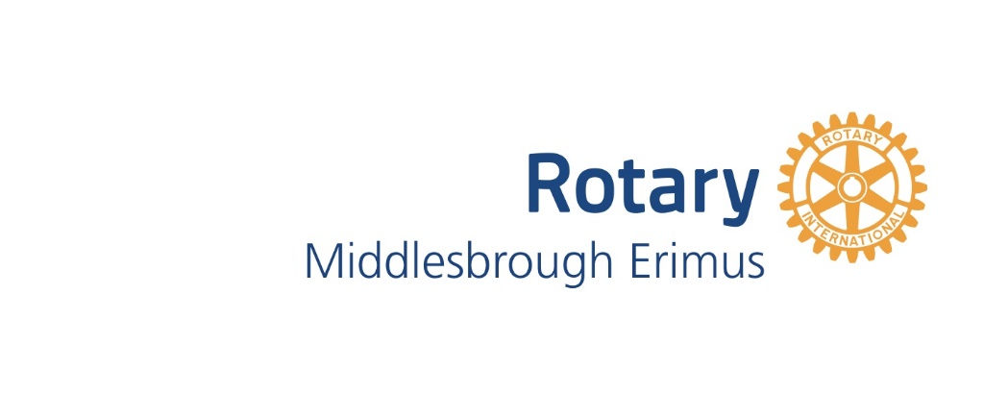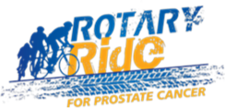
Middlesbrough Erimus Rotary is supporting the Rotary Ride for Prostate Cancer and also offering local charities an opportunity to raise funds for their own causes.
The 2021 Rotary Ride will take place on the 1km cycle track at Sports Village, Marton, Middlesbrough
On Sunday 5th September 2021
ENTRY FORM
Individuals, families and Groups are invited to join.
Group Lead/Family Lead or Individual Name | Contact number | Email
Name of Charity supported:

Group Member Name | Contact number |  | Email
Preferred start time:  (Please circle) | 9am | 10am | 11am | 12noon | 1pm | 2pm | 3pm | 4pm
Please note that actual start times will be allocated on receipt of entry forms and may vary slightly from those requested. Any changes will be notified to Group leads.

Please email your completed form to: rotaryride@erimusrotary.org.
Any queries please email or phone 07954689662
Rotary Ride is an annual event promoted by Rotary in Great Britain and Ireland and traditionally funds have been raised to support Prostate Cancer Charities across the UK and Ireland. We are changing the rules a little this year to also support other local charities. All participants should state which charity they want to support and all sponsorship money they personally raise will go to that charity. Entries can be submitted either individually or via the chosen charity.

